**INVISIBLE CLOAK USING COLOR DETECTION AND SEGMENTATION USING OPENCV**



NAME : M. Sai Priya

ROLL No. : 20951A3342

BRANCH : CSIT

***ABSTRACT:***

An invisibility cloak is a hybrid of science and magic. The collective imagination, as well as fantasy. This publication contributes to the creation of one's own cloak of invisibility Python and other programming languages will be used. Image Processing is a focus of the OpenCV module. Image segmentation is used to give the illusion of invisibility. frame. It will look at how a given color or texture affects an object. Python's OpenCV package can be used to edit the data. To do so, we'll start by capturing and storing the data. frame for the backdrop. Following that, we'll look for the red-colored items. Using the algorithms discussed above, fabric can be created. Then we'll create a mask to section out the red-colored fabric. Finally, we'll generate the final enhanced version (magical). To make an invisibility cloak, use the output. These processes are covered in detail. a little further into the paper.

***KEYWORDS:***

OpenCV, Invisibility Cloak, Image Processing Python.

***INTRODUCTION:***

Computer vision emerged in the late 1960s as Artificial Intelligence progressed. Its sole objective was to improve the intelligence of the artificial mechanisms by incorporating cameras into them. and explain what they saw in the same way that people do with their visual system. As a result, computer vision should be able to discern real-life 3D objects from 2D images. Every image offers us a tale about something that is happening right now or what has happened in the past. been going on at a certain point in time Python's OpenCV library is a computer vision library.

**LITERATURE SURVEY:**

* The year 1999 marked the start of Intel. Since then, it has been updated with new changes. C and C+, two different versions of C, were used to construct this library.
* It is compatible with a wide range of operating systems. There are options for Windows and Linux. It's really easy to use this library.
* In addition to Numpy and Python, programming languages such as Python, MATLAB, and Ruby are examples of programming languages. It's simple to process (color and shape recognition).

**EXISTING METHOD:**

Why the color red? My favorite color is green. Sure, we might have gone with green, but isn't Red the color of the magician? Aside from the jokes, colors like green or blue will also function nicely with a few code tweaks.

Green Screening is the polar opposite of this procedure. We eliminate the background in green screening, but we will not remove the foreground frame here.

**PROPOSED METHOD:**

The method of operation is diametrically opposed to the concept of green screening. The background is removed, much as it is in green screening, but we also remove the foreground in this application. For this use, a red colored material is employed as a cloak. With a few code tweaks, we can use any color we want.

**PROBLEM STATEMENT :**

Because the RGB values are quite sensitive to light. This does not appear to be working as quickly as it once did. Despite the cloak's red hue, there may be certain locations where the red channel values of the associated pixels are a little low owing to shadow.

**IMPLEMENTATION STEPS:**

The steps to make an invisible cloak are as follows:

* Import the required packages and set up the camera.
* Before beginning the infinite loop, save a single frame.
* Create a mask based on the colour of the material.
* Place the mask on the frames.
* Assemble the masked frames.
* Unnecessary noise is removed from masks.

**ALGORITHM:**

* Take a picture of the background and save it. [This will last a few seconds.]
* Using a colour recognition and segmentation method, find the red coloured cloth.
* Create a mask to separate the red coloured cloth [used in code].
* Create a magical effect by generating the ultimate increased result.

**FLOWCHART:**



## 











**RESULTS AND CONCLUSIONS:**

Our major goal is to substitute the current frame pixels corresponding to the cloth with the backdrop pixels to produce the effect of an invisibility cloak; in order to do so, we'll use a combination of techniques. A frame of the backdrop must be saved. Since we're making use of we used a crimson fabric to turn it into an invisibility cloak. It would be drawn to the discovery of red in the frame.We'd start by capturing a live frame and then changing the picture from R.G.B. to H.S.V. color space, and then specify an output device in order to recognize the required range of 'H.S.V' values of the color red.

**CONCLUSION:**

Computer vision can be utilized to solve even the most complex problems in the most sophisticated way. In the study, all of the principles of the color detection approach, as well as various approaches to attaining it, are thoroughly covered. We utilize both Python and MATLAB for Computer Vision, we favor Python. Python is favored over MATLAB since it takes less time to simulate. It is straightforward to implement for someone with prior coding skills.

**FUTURE SCOPE:**

Because computer vision is still in its early stages of research, it has not yet reached the point where it can be used to tackle real-world problems. It can also be widely employed in Augmented Reality applications.

The following are some of the applications:

* To create spectacular graphics, video editing and media are used.
* The "Infinity Tower" is a South Korean skyscraper that can't be seen (under construction)

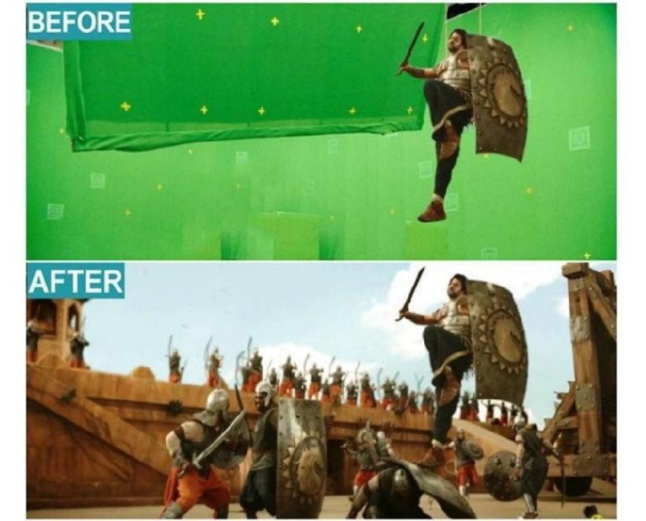

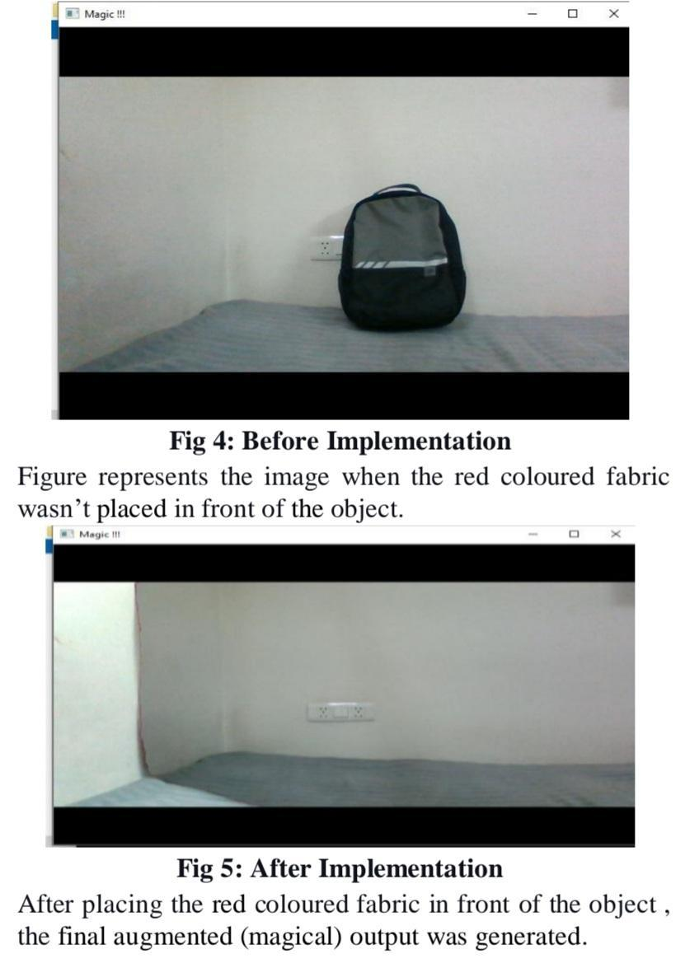

**REFERENCES :**

1. (PDF) Facial Recognition using OpenCV. (2012, March 1). Retrieved from https://www.researchgate.net/publication/267426877_Facial_Recog nition_using_OpenCV

2. AUTOMATIC IMAGE PROCESSING ENGINE ORIENTED ON QUALITY CONTROL OF ELECTRONIC BOARDS. (n.d.). Retrieved from https://www.academia.edu/36556406/AUTOMATIC_IMAGE_PRO

CESSING_ENGINE_ORIENTED_ON_QUALITY_CONTROL_O F_ELECTRONIC_BOARDS